Живі книги:

https://drive.google.com/file/d/1hntoIHTc-p2U73B8m2BA6lNL532aQI22/view?usp=drive_link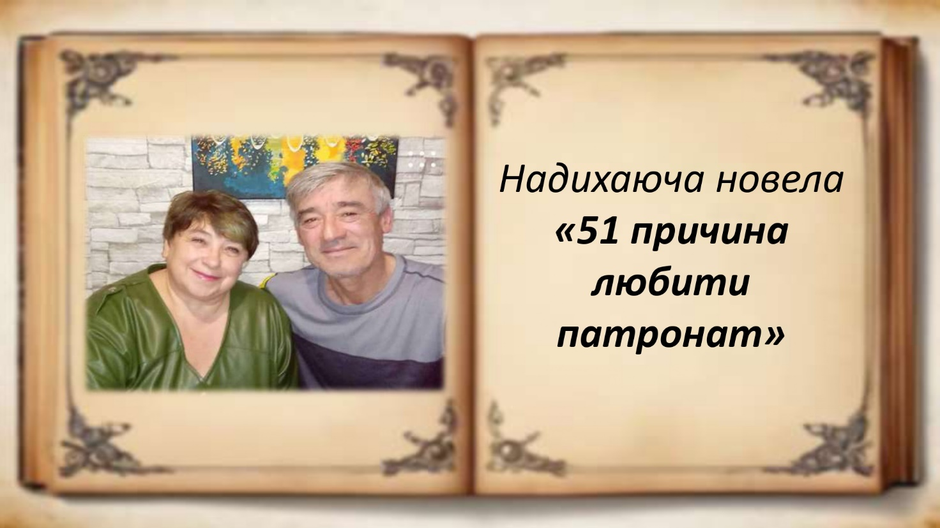

https://drive.google.com/file/d/1aDS4ACu0Psj1VuSdVSqJica-_nKcvN4c/view?usp=drive_link
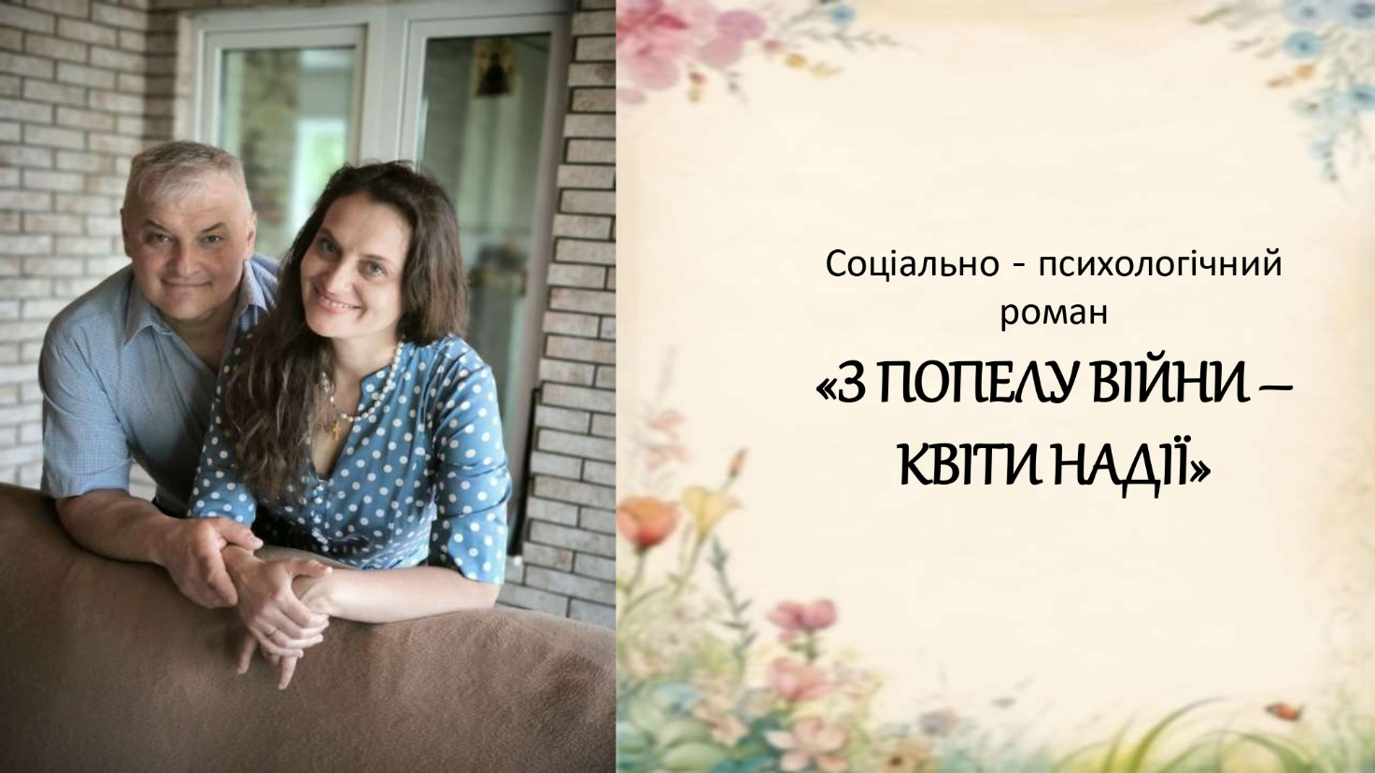

https://drive.google.com/file/d/1Kn2VQMrgC0zM2Q0e0uB8DlnrdpykH7_D/view?usp=drive_link
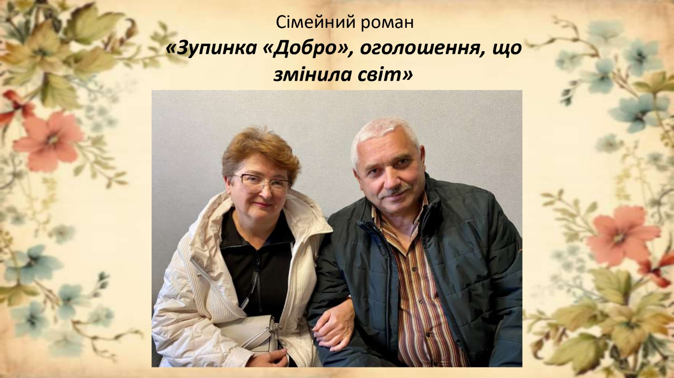

https://drive.google.com/file/d/19WXhioJ8jEZiCJBoKWroSKVgjTOMM2ZV/view?usp=drive_link
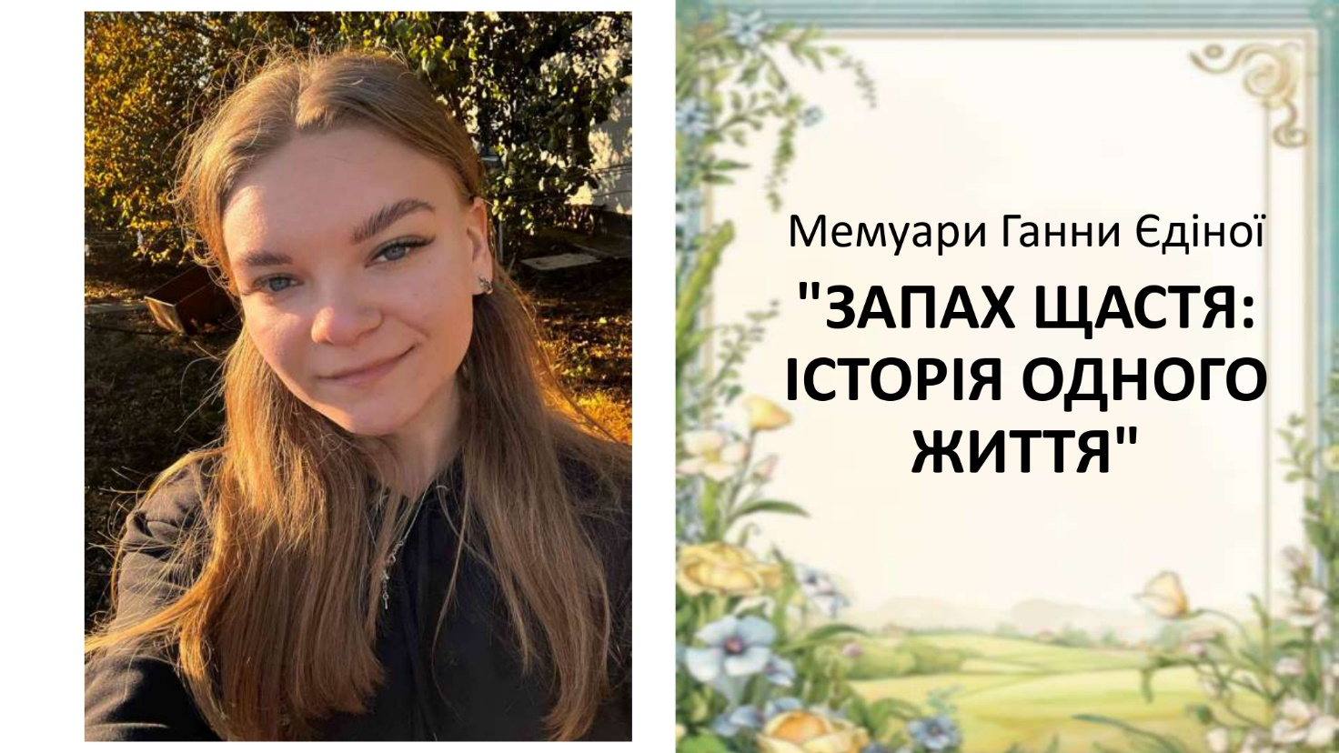

https://drive.google.com/file/d/102E7SUQbZczY-QsxA9QHMJePO6Ie9QVP/view?usp=drive_link
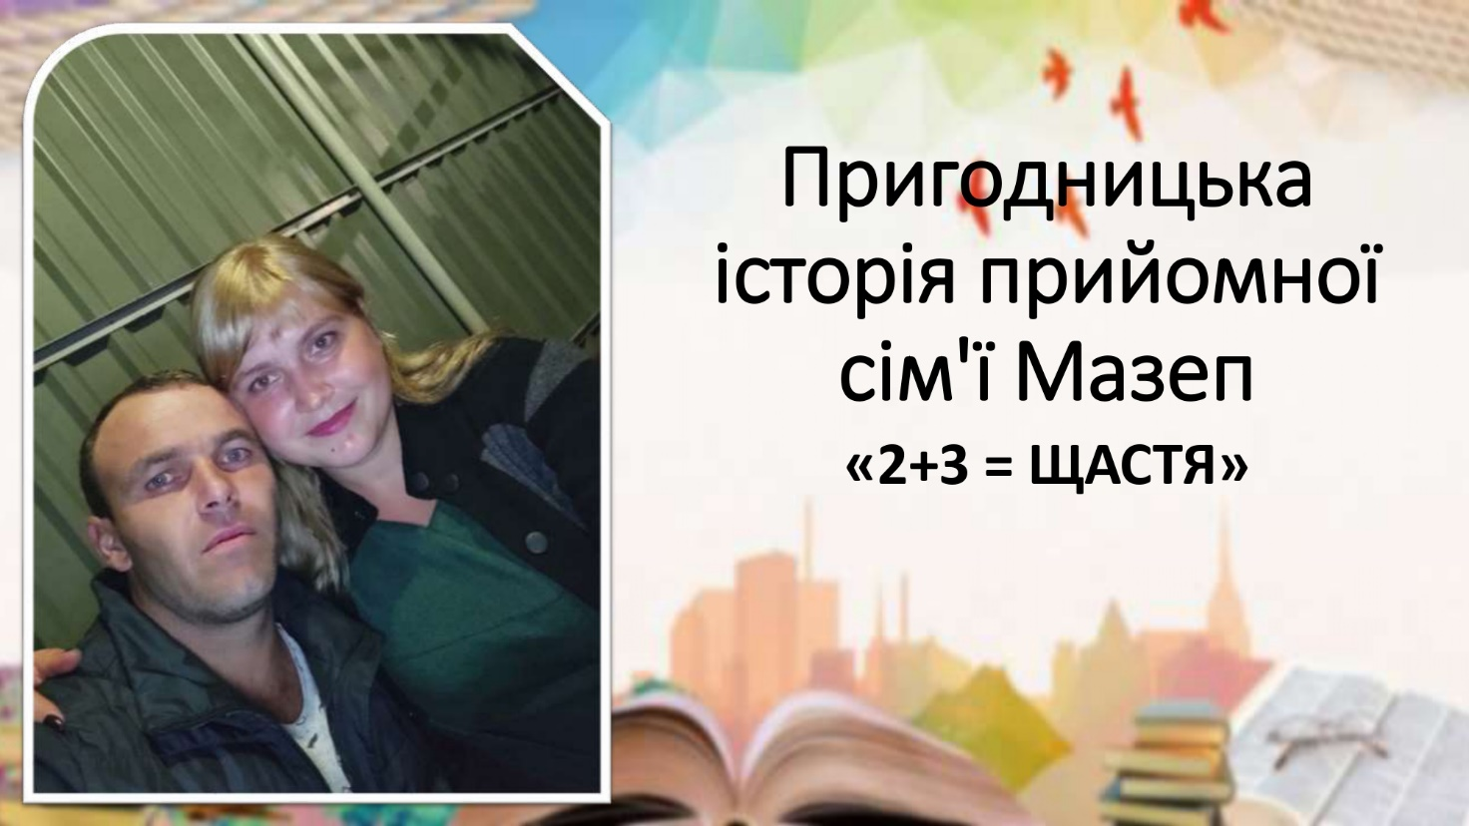

https://drive.google.com/file/d/17rlL_tEIpjIlaY3IyJnfLqDK1wNiS1jr/view?usp=drive_link
